**TIC TAC TOE**

PROJECT MEMBERS:

GULZAR BALOCH [21K-4542]

DEEPAK CHAWLA [21K-4931]

BHAVISH KUMAR [21K-3450]

I have made named as “tic tac toe” as my final project. I have selected my project as per my interest and I have found many new things for my code from my seniors. I have used functions, arrays, loop and conditional statements to come to result of my project. Project solution will be shown like there would be a table formed where a user will input his/her choice; our project code is written as it will ask both players to input their desired place and decide whether the player 1 or 2 has won and also it will specify a wrong move

Game’s view

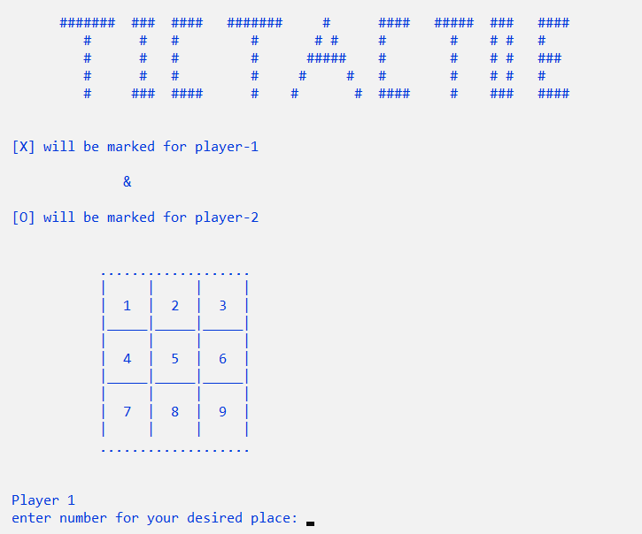

If player 1 is winning

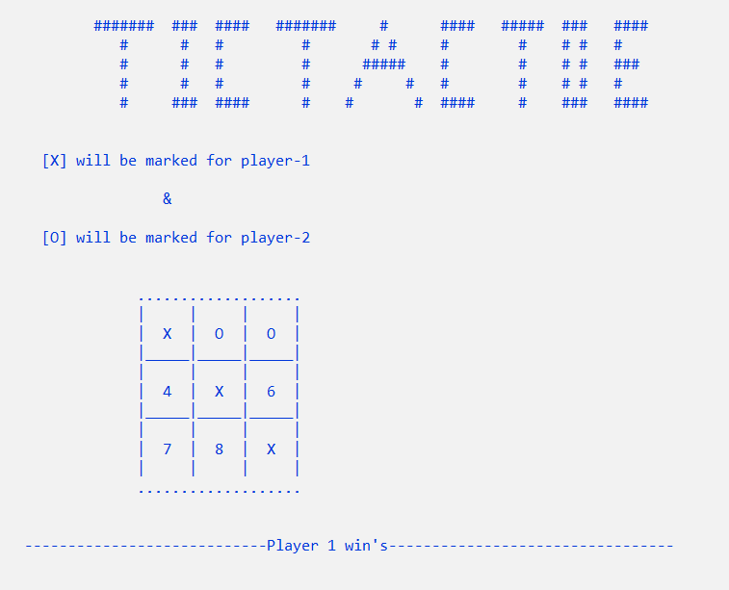

If player 2 is winning

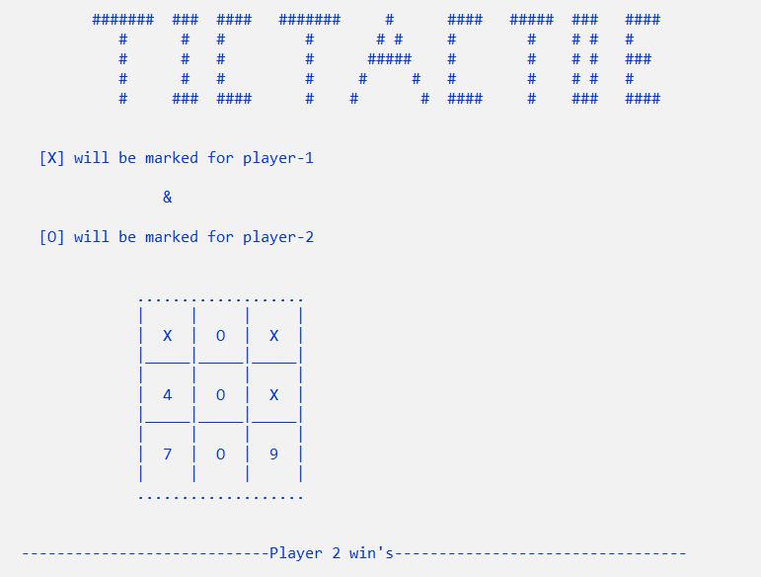

If game is draw

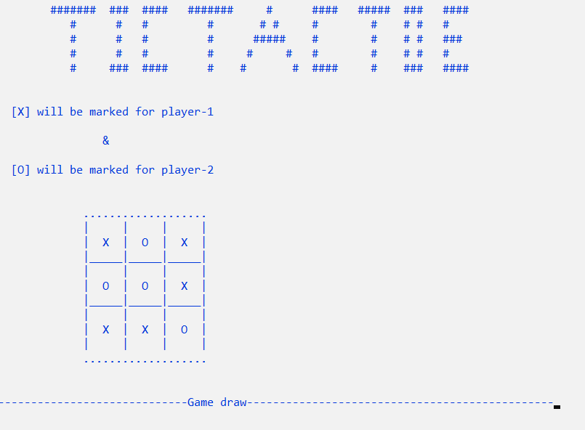

*Our project took maximum 15 days to complete and our most of time taken by table to be formed. Conclusion: we come to know many things and our practice among many topics went to a next level*.